NEUMERA
Longitudinal women’s health & AI coaching
Pregnancy & Postpartum Module
Two-mode engine — functional architecture, screen layouts, and feature build notes
For dev-team and compliance review

Purpose of this document. This spec describes the Pregnancy & Postpartum module as a single engine with two modes and a hard pivot at birth, whose defining feature is clinical symptom triage rather than tracking. It covers the module architecture and per-feature build (including a considered position on fetal-movement / “kick” tracking), the AI-coach overlays, three reference screen layouts (the pregnancy “Today” hero, the red-flag triage moment, and the postpartum “Today” hero), a regulatory flag for counsel, and a ready-to-run Cowork prompt. Screens shown are design references for the build team, not final production assets.
Stage framing. User-facing, this stage reads: tracking the body’s rapid changes and supporting recovery through one of life’s most demanding chapters.

0 · Data Privacy & Zero-Retention
Privacy is a first-class design principle across every Neumera module, not a compliance afterthought. The commitments below are inherited from Neumera’s core platform and privacy architecture and restated here so this document stands on its own for diligence review. They govern every feature in this specification.

Zero-retention AI
The AI keeps nothing; your account does. All AI inference runs on AWS Bedrock over private connectivity (VPC PrivateLink), under a signed Business Associate Agreement verified through AWS Artifact, with no retention of prompts or outputs by the model or the provider. The inference layer is stateless; durable value lives only in the user’s own longitudinal record. This is how zero-retention inference is reconciled with durable longitudinal storage — the record persists, the AI does not.

Trust domains and the de-identification gate
Data is separated into three trust domains with an isolated linkage store, so identity and health signal are never co-resident where the AI can see both. A fail-closed de-identification gate sits on any payload crossing from the identity zone to Bedrock: if the gate cannot strip identity, the request does not proceed.
Precision note. The platform’s privacy claims currently rest on pseudonymized status — not “de-identified” or “anonymized” — pending completion of the HIPAA §164.514(b)(1) Expert Determination scoping the AI-bound payload. Documentation and UI copy should use “pseudonymized” until that determination completes.

Regulatory posture
The FTC Health Breach Notification Rule is the primary regime at launch (no covered-entity or business-associate relationship, and no EU/UK presence at launch); HIPAA Security Rule practices, Washington’s My Health My Data Act, and GDPR readiness are maintained as the footprint expands, backed by an incident-response plan with breach-notification steps.

Commercial data boundary
The B2B provider-advertising layer targets geography and life-stage context only — never individual health signals. No module’s health data is used for ad targeting.

Highest-sensitivity data in this module
Pregnancy status and dating, symptom and red-flag triage logs, EPDS mental-health scores, and pregnancy-loss status — among the most sensitive data the platform holds, handled with the strictest access controls. Loss status in particular must never leak into celebratory content, notifications, or third-party surfaces.

1 · Architecture — two modes, one engine
This is not one module. It is two products joined at a single event. Pregnancy is forward-looking, week-by-week, baby-oriented, escalating toward term, and anxiety-laden. Postpartum — the “fourth trimester” — is recovery-oriented, mother-focused, sleep-deprived, and carries acute mental-health risk. They serve different users in different states, with different tones and different dangers. So the defining architectural move is a hard mode switch at birth: the app changes what it shows, from “your baby this week” to “how you are healing.” Build one engine with two modes and a pivot at delivery — not one continuous timeline.
The defining feature is triage, not tracking. Pregnancy has genuine red flags that need immediate care — severe headache with vision changes (preeclampsia), bleeding, reduced fetal movement, pre-term contractions. The symptom monitor cannot merely log; it needs an escalation layer that recognizes danger signs and routes to care now — while never diagnosing, never inducing panic over normal symptoms, and never falsely reassuring. That razor’s edge is the module. Postpartum carries its own: postpartum preeclampsia and hemorrhage, and postpartum depression/anxiety/psychosis, where validated screening (the Edinburgh Postnatal Depression Scale) is standard of care.

Feature-to-stack mapping
Confirmed stack: Laravel API core + Python/FastAPI internal ML microservice (async boundary, Python internal-only) + Flutter client. Ingestion via HealthKit / Health Connect (Flutter health plugin) and Terra API for cloud wearables.
- Pregnancy week tracking — Weeks/trimester from EDD (dating from the Cycle engine); gestational-age math in Laravel; week-by-week development content served from the vetted EVP corpus, not generated. The emotional anchor of pregnancy mode.
- Health checkpoints — Standard prenatal cadence (monthly → biweekly → weekly) and the screening timeline (NT scan, ~20-week anatomy, ~24–28-week glucose, ~36-week GBS, Tdap), each with “what happens and what to ask.” Postpartum: the 6-week visit and newborn visits. Useful and low-risk — a schedule plus preparation, not medical advice.
- Sleep tracking — Terra/HealthKit, but the framing shifts with mode: discomfort is expected in pregnancy; fragmentation is universal postpartum. The honest job is normalizing it and correlating with mood, not scoring against a healthy-adult baseline she cannot hit.
- Symptom monitoring — Ordinary symptoms logged as trends, but every entry evaluated against a red-flag rule set (clinically defined, EVP-owned) that escalates danger signs to a “contact your provider now” path. Deterministic rules first — not a place for a probabilistic model.
- Nutrition reminders — General wellness only: folate/iron, hydration, food-safety reminders. Not prescriptive diet plans, and must respect provider-individualized needs (e.g. gestational diabetes). Wellness-side language, same discipline as the other modules.

The kick tracker — movement awareness, not a daily count
You were right to question this. Reduced fetal movement is genuinely associated with stillbirth risk, and “know your baby’s pattern and report reduced movement promptly” is sound clinical advice. But formal routine kick-counting as an intervention has mixed-to-poor evidence — the largest trial of a count-and-manage package did not reduce stillbirth and was associated with more obstetric intervention and maternal anxiety, and systematic reviews have found insufficient evidence that routine formal counting helps. (The clinical lane should confirm against current ACOG/RCOG guidance.) A rigid daily count risks three failure modes: it manufactures anxiety, it can falsely reassure (she logs “10 kicks” and dismisses a real decrease), and it implies a medical threshold Neumera would be defining.
The defensible design — which is also the platform’s N-of-1 philosophy: help her learn her baby’s normal pattern, surface it only in the third trimester, and make the important action a fast “movement feels different? → contact your provider now” path rather than a number. The value is catching a change and routing to care, not the count.

One ethics requirement: pregnancy loss
The app cannot keep cheerfully counting weeks or pushing “your baby is the size of a lime” notifications after a miscarriage or stillbirth. There must be a gentle, non-triggering way to pause or adjust the experience, and a loss must immediately silence the celebratory machinery. Getting this wrong is both deeply harmful and reputationally catastrophic. It belongs in the build, not a later pass.

2 · The AI coach — two overlays, tightest guardrails
As with the other modules, the coach is the existing platform component (per the patent’s layered base-prompt + life-stage-overlay orchestration, Bedrock, zero-retention, cost-routed, tier-metered), not a new build — but here it needs two overlays, pregnancy and postpartum, that swap at the birth pivot, and it carries the tightest guardrails of any stage.
- Retrieval-grounded, never generative. Development notes, checkpoint “what to ask” content, and any clinical answer are drawn from the vetted EVP corpus; the coach never free-generates medical guidance.
- Wired into the safety paths. The coach is the voice of the red-flag triage escalation and the postpartum EPDS path, exercising the patent’s post-inference guardrail filtering and clinical escalation harder than any other stage.
- Off-quota summaries. Week-by-week development and checkpoint prep are coach-authored automated summaries and do not count against her interaction cap; user-initiated coaching does.

3 · Screen layout — pregnancy “Today” hero
The forward-looking pregnancy surface. Warm, week-anchored, with movement awareness handled as pattern rather than count.
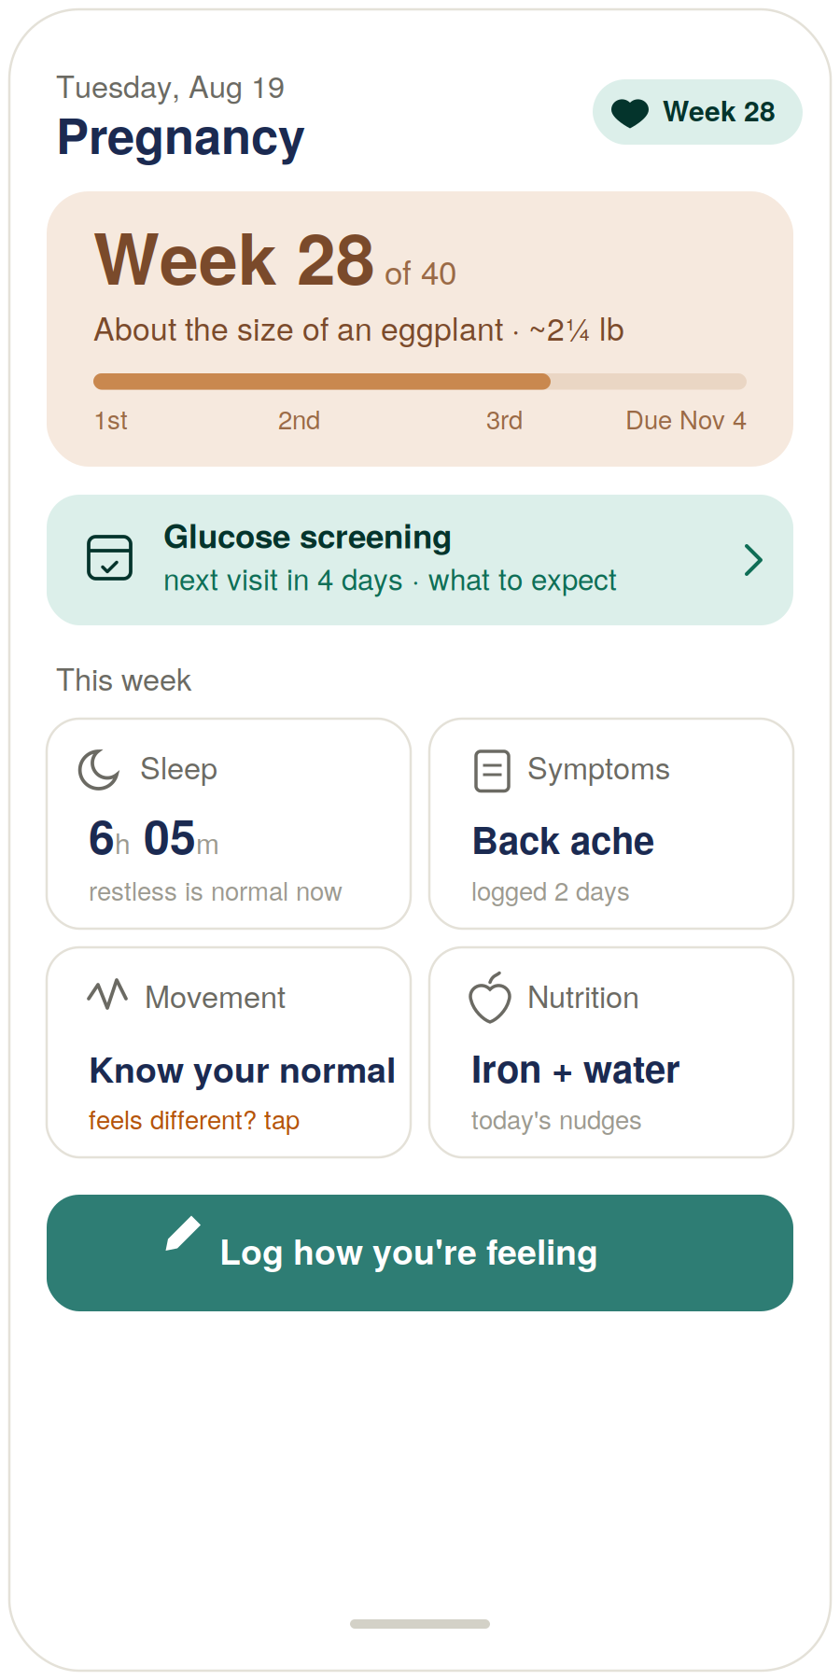
Figure 1 — Pregnancy “Today” hero view (design reference).

Build notes
- The week is the emotional anchor. Baby development and progress-to-due-date lead, because that is what she opens the app for; the vetted content behind it is coach-surfaced, not generated.
- Checkpoints are prep, not advice. The next-visit card (“glucose screening · what to expect”) orients and prepares her rather than instructing her clinically.
- Sleep is normalized. “Restless is normal now” — framed against pregnancy, not against an adult baseline she cannot hit.
- Movement is awareness, not a count. “Know your normal · feels different? tap” — third-trimester pattern awareness with a fast route to concern, per the evidence position above. No daily quota, no gamified counter.

4 · Red-flag triage screen
The highest-stakes screen in the platform, and coach-voiced. It surfaces when a logged symptom trips the clinical red-flag rule set.
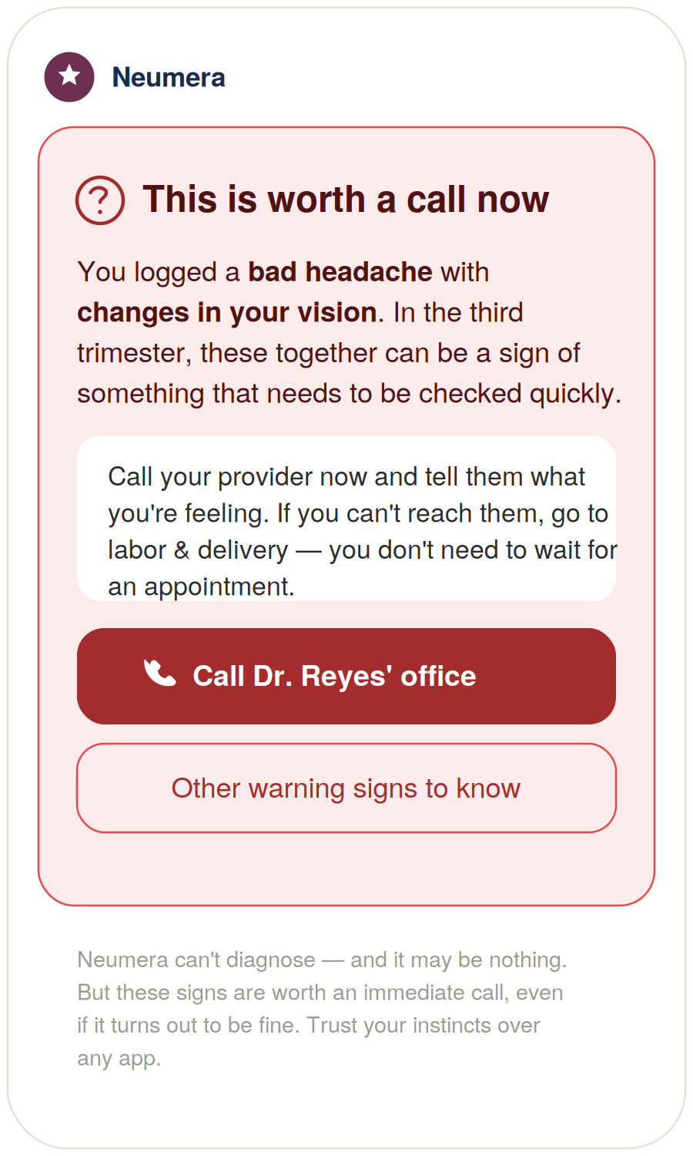
Figure 2 — Red-flag triage screen (design reference).

Build notes
- Urgency without panic. Serious red framing, but calm plain language and a concrete action rather than alarm.
- It names what she reported. “A bad headache with changes in your vision” — so the escalation feels earned, not random.
- Routes to care with a fallback. Call the provider; if unreachable, go to labor & delivery. The failure mode of these moments is a woman waiting for an appointment. The call button is primary and pre-filled with her saved provider.
- The footer does three jobs. It disclaims diagnosis, prevents panic (“it may be nothing”), and — most important — tells her to trust her instincts over the app.
The rule set is EVP-owned, deterministic, and conservative-but-not-trigger-happy. Too many false alarms and she mutes it — the worst outcome. That calibration is a clinical decision, not an engineering one.

5 · Screen layout — postpartum “Today” hero
The birth pivot. The surface shifts to the mother’s recovery and mental health.
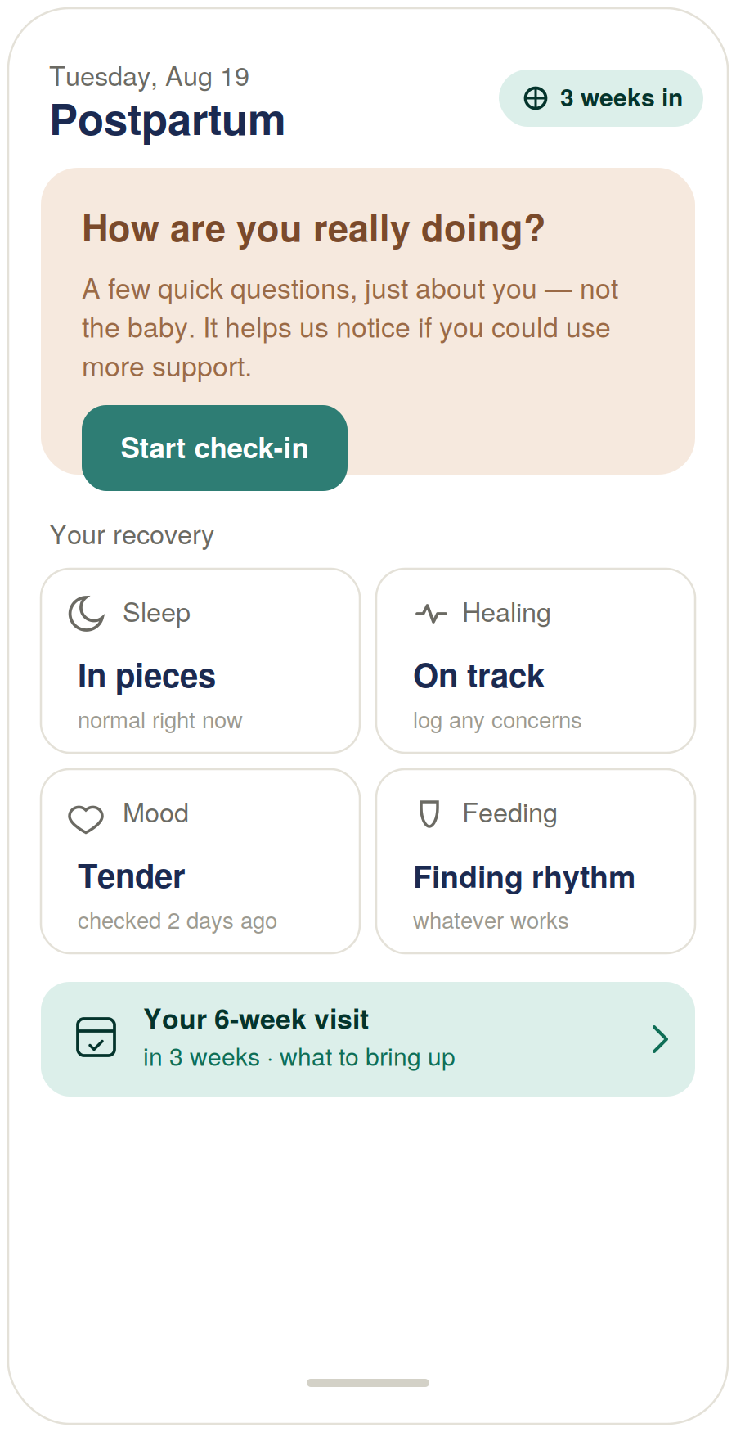
Figure 3 — Postpartum “Today” hero view (design reference).

Build notes
- The hero is her, not the baby. “How are you really doing? … just about you, not the baby” is the EPDS screening wrapped in language a depleted new mother will actually tap.
- Normalize, don’t score. Sleep “in pieces — normal right now,” mood “tender,” feeding “whatever works” — a deliberate refusal to take sides in the breast-vs-bottle pressure that harms maternal mental health.
- Newborn tracking stays light. The market is saturated with baby trackers; the differentiator is being the app that watches out for the mother.
- EPDS is the higher-acuity sibling of the menopause mood path. A validated instrument, scored, with a clear escalation path to support; threshold and cadence are EVP clinical decisions, with an always-available crisis resource that promises nothing it cannot keep.

6 · Regulatory flag — for counsel
This is the module where the gap between “wellness app” and “medical device” is narrowest, and it should be on the diligence record before this module ships.
⚠ Software-as-a-Medical-Device (SaMD) review required before launch
Issue. Two features in this module — the symptom triage / red-flag escalation layer and the EPDS-based postpartum screening — perform functions that, depending on how prescriptive they become, can fall within the FDA’s definition of Software as a Medical Device. Software that analyzes user-entered signs and drives a clinical recommendation (“contact your provider now”) or applies a validated screening instrument to flag a condition sits closer to the regulated boundary than ordinary tracking and education.
Why it matters here specifically. Regulators scrutinize pregnancy- and mental-health-adjacent software hardest. The same triage design that makes the product safe and valuable — recognizing danger signs and routing to care — is also what draws regulatory attention. The mitigation is not to weaken the feature but to design and document it deliberately: inform-and-route rather than diagnose, defer explicitly to the user’s clinician and instincts, and keep the clinical logic and its provenance auditable.
Recommended action. Have regulatory/privacy counsel review the triage and EPDS features specifically before this module ships, including whether current framing keeps them within a wellness/CDS exemption or requires a different posture. Nothing else in the module should block launch on this basis; these two features should.

7 · Cowork build prompt (consolidated)
Drop this into Cowork to produce the full diligence-grade Pregnancy & Postpartum module specification. The three screens above are referenced as Exhibits A–C, and the regulatory flag is carried into the compliance section.
Task
Produce a diligence-grade functional and technical specification document for the Pregnancy & Postpartum life-stage module of the Neumera women’s health app, for our contract dev team and compliance reviewers. Match our established document system: navy and Sand Gold brand colors, Fraunces for headlines, Inter for body. First review our existing spec documents (the Athlete and Perimenopause/Menopause module specs, the Cycle/Fertility Section 7 functional spec, the health data ingestion architecture spec, the graceful-enrichment doc, and the AI coach patent specification) so this module is stylistically and architecturally consistent — it must interoperate with the Cycle & Fertility engine for pregnancy dating and reuse the platform AI coach.
Architecture — two modes, one engine
Specify the module as a single engine with two modes, Pregnancy and Postpartum, and a hard mode switch at birth that changes the entire surface from baby-development/forward-looking to maternal-recovery/mental-health focus. The defining feature is not tracking but symptom triage: a clinically-defined, EVP-owned, deterministic red-flag rule set that escalates danger signs to a “contact your provider now” path without diagnosing, without inducing panic, and without false reassurance.
The features
Health checkpoints, pregnancy week tracking, sleep tracking, symptom monitoring (with the triage layer), nutrition reminders, and fetal-movement awareness.
Stack
Laravel API core, internal Python/FastAPI ML microservice (async boundary, Python internal-only), Flutter client. Sources: HealthKit / Health Connect via the Flutter health plugin, Terra API for cloud wearables, plus manual symptom/mood/sleep logging. AI on AWS Bedrock under the zero-retention pattern with the de-identification gate on any payload crossing to Bedrock.
Per feature, specify
Inputs, computation and where it lives (deterministic FastAPI/rules vs. Bedrock), durable-record storage, and Flutter UI. Pregnancy week tracking: gestational age/trimester from EDD (dating from the Cycle engine); week-by-week development from the vetted EVP corpus, not generated. Health checkpoints: standard prenatal cadence and screening timeline (NT, ~20-wk anatomy, ~24–28-wk glucose, ~36-wk GBS, Tdap) and postpartum/newborn visits, each with “what happens / what to ask.” Sleep: Terra/HealthKit, mode-aware framing (discomfort expected in pregnancy; fragmentation normalized postpartum), correlated with mood rather than scored. Symptom monitoring: ordinary symptoms as trends; every entry evaluated against the red-flag rule set; specify the escalation UI and the conservative-but-not-trigger-happy calibration as an EVP clinical decision. Nutrition: general wellness only (folate/iron, hydration, food safety); not prescriptive diet plans; respect provider-individualized needs. Fetal-movement awareness: NOT a gamified daily kick-count — evidence for routine formal counting is weak-to-mixed and risks anxiety, false reassurance, and implying a Neumera-defined medical threshold; specify movement awareness (learn her baby’s normal pattern, third-trimester only, primary action a fast “movement feels different → contact your provider” path); have the clinical lane confirm against current ACOG/RCOG guidance.
AI coach — two overlays, tightest guardrails
Specify the module’s coaching as the existing platform coach (patent’s layered base-prompt + life-stage-overlay orchestration, Bedrock, zero-retention, cost-routed, tier-metered) with pregnancy and postpartum overlays that swap at the birth pivot. Retrieval-grounded in the EVP corpus, never free-generating medical guidance, wired into the red-flag escalation and EPDS paths. Development notes and checkpoint prep are coach-surfaced automated summaries, off-quota.
Module-specific requirements
Postpartum mental health — specify validated EPDS-based screening in postpartum mode, scored, with a clear escalation path to support; threshold and cadence are EVP clinical decisions; always-available crisis resource that makes no confidentiality or outcome guarantees. Pregnancy loss — specify a gentle, non-triggering way to pause or adjust the experience on miscarriage or stillbirth, which immediately silences celebratory content and notifications; a first-class requirement. Maternal focus postpartum — the differentiator is watching out for the mother; keep newborn tracking light; normalize rather than score sleep, mood, feeding (no breast-vs-bottle bias). Compliance framing — tracking, checkpoints, and education are informational wellness, not medical advice or diagnosis; the triage layer routes to care and explicitly defers to the user’s provider and instincts. Phased build: deterministic tracking, checkpoints, triage rules, and EPDS first; any models deferred.
Regulatory flag to carry into the compliance section
Include an explicit flag that the symptom-triage / red-flag escalation layer and the EPDS-based postpartum screening may fall within the FDA’s Software-as-a-Medical-Device (SaMD) definition depending on how prescriptive they are, and require regulatory/privacy counsel review before launch. Frame the mitigation as inform-and-route rather than diagnose, explicit deference to the user’s clinician and instincts, and auditable clinical logic and provenance — not weakening the feature. State that these two features (not the rest of the module) should gate launch on this review.
Reference exhibits to include and build against
Exhibit A — Pregnancy “Today” hero (Figure 1): week/trimester tracker with baby development and progress to due date; next-checkpoint card; weekly snapshot (sleep normalized, symptoms, third-trimester movement awareness, nutrition nudges); a feeling-log action. Warm, forward-looking palette.
Exhibit B — Red-flag triage screen (Figure 2): coach-voiced, urgent-but-calm; names the reported symptoms; urges contacting the provider now with an L&D fallback; primary “call your provider” action pre-filled; footer that disclaims diagnosis, prevents panic, and tells her to trust her instincts over the app.
Exhibit C — Postpartum “Today” hero (Figure 3): the birth pivot; hero is a maternal wellbeing check-in (“how are you really doing — just about you”); recovery snapshot normalizing sleep/healing/mood/feeding; the 6-week visit framed as hers; newborn tracking intentionally light.

Practical note. Cowork cannot ingest the three rendered screens as images from the chat directly — either describe Exhibits A–C in the prompt (as done above) or attach Figures 1–3 from this document to the Cowork session as visual references.

